After we get the tweets from mango database, we started to analyze it.

First, we found out what’s the most frequency word among these tweets, which mean when people are talking about Patriots, what are they talk about exactly. Then we compute the frequency of words in twitters and plot the first 30.

In order to avoid meaning-less words such as “I”, “The” and “at” appear in our plot result, we import a package named nltk to eliminate these words.

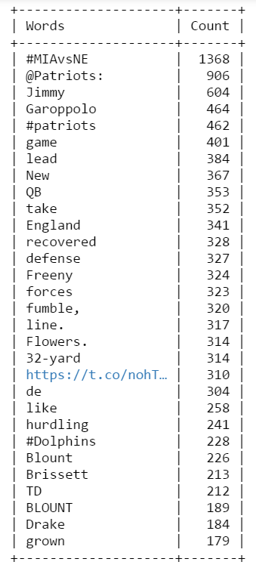

Then we count and listed 10 tweets with the most retweet numbers.

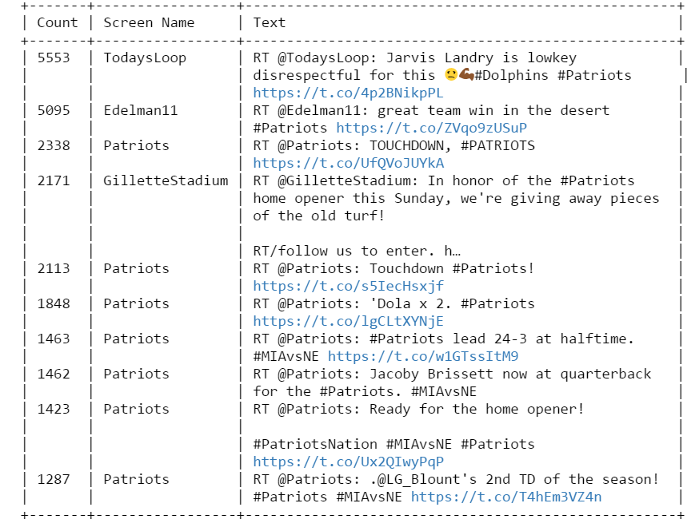

For the most popular tweet entities analysis, we plot the 10 most popular hashtags and 10 most popular user mentions.

